**selecting a fast-food franchise outlet**

**at hibiscus and bays area**

*Chap Micua*

*Version 1.0*

*September 2020*

1. **Contents**

**2.** **Document Control** 5

1. Disclaimer 5

2. Introduction 5

3. Strategy Justification 7

4. Strategy Summary in 5 Steps 8

5. Define the Customer 9

6. Area Selection and Elimination 9

7. Battle of the Neighbourhoods 14

8. STANMORE BAY 30

8.3. CHALLENGES**:** 40

8.4. RESULTS 40

8.5. FINAL THOUGHTS 41

1. **Document Control**

|  |  |  |  |
| --- | --- | --- | --- |
| **Document Version:** | **Changes By:** | **Position** | **Date** |
|  |  |  |  |
|  |  |  |  |
|  |  |  |  |
|  |  |  |  |
|  |  |  |  |

# Disclaimer

# This study was prepared and accomplished by Chap Micua in his personal capacity. The opinions expressed in this study are the author’s own and do not reflect the view of the fast-food franchise or his current employer.

# The material and information contained in this study is for the purposes of submitting the final project for the IBM Capstone course only. Any and all entities should not use and rely upon any and all information in this study as a basis for making any business, legal or any other decisions. Any reliance placed on this study is strictly at your own risk. The author will not be liable for any false, inaccurate, inappropriate, or incomplete information presented in this study.

# Introduction

This study is a capstone project of the Coursera IBM Data Science Professional specialization.

This study assumes an entity entering a franchise with New Zealand’s Restaurant Brands[1] and has chosen to partner with the fast-food franchise to establish a franchise outlet somewhere in the Hibiscus and Bays region.

Hibiscus and Bays[2] covers much of the eastern side of Auckland's [North Shore](https://en.wikipedia.org/wiki/North_Shore,_New_Zealand) and includes suburbs that make up the Hibiscus Coast and East Coast Bays. The total population residing in this area is estimated at 109900 with a 2019 growth rate of 2.6%. It has an economy of NZ$ 1.853B with a 2019 growth rate of 4.8%. There are 11,760 business units with a 2019 growth rate of 1.7%. It has 24 primary and intermediate schools.[3]

# Purpose

This document concisely outlines the process of selecting a location of the fast-food franchise at Hibiscus and Bays area, Albany Ward, Auckland, New Zealand using Foursquare and other relevant location and demographic data.

# Audience

This document is intended for

* Solely for IBM data analytics practitioners reviewing this analysis for the capstone project.

# Scope

The document includes the following:

# Strategy Justification

# Identification of the fast-food franchise’s New Zealand target customers based on their demographics through the fast-food franchise’s recent NZ advertisements

# Short listing of feasible areas (from henceforth shall be called “target franchise areas”) at the Hibiscus and Bays area by identifying those that meet council and franchise requirements.

# Assessment of target franchise areas by comparing them and with similar existing franchise areas based on target customer demographics

# Selection of most appropriate the fast-food franchise target franchise areas in the Hibiscus and Bays area based on relevant factors identified in this study.

It excludes the following:

# Areas outside the Hibiscus Coast and Bays shall be excluded in the selection of target areas; however, they shall be used to benchmark the current selection against markets with existing outlets based on the size of target demographics.

# Cost of rental property, operational cost and potential profit will be excluded in this study because of lack of available data and will not be a factor in determining the location of the franchise.

# Strategy Justification

While many studies[4],[5] on restaurant and franchise location selection highlight area features such as visibility, security, proximity to parking space, and competitors in the area, most of them fail to address the demographics of the target customers, their relative numbers nor their proximity to a candidate outlet. They do not address local council zoning restrictions as well as did not address franchise requirements (as is the case of franchise fast food outlets) that define the minimum distance from other franchise outlets.

So what?

Failure to identify the target customer demographics and their proximity to the candidate outlet will not ensure that the analyst is targeting the correct demographics nor enough of them are close to a candidate outlet. In the U.S., a study[6] involving 135 participants in 5 cities has shown that “*the average distance between the food establishments and homes was 2.6 miles* (or 4.18 km) *(standard deviation, 3.7 miles)”*. This correlates quite well with another U.S. study[7] indicating that, on average, the customer travels around 8.4 minutes to a fast-food outlet. The same study indicates that the more frequent the purchase, the less the consumers are willing to travel.

While these studies clearly refer to American customers, unfortunately studies about New Zealand customer behaviours are rare and not publicly available. It is therefore assumed that American customer behaviour do not stray far from those of New Zealand customers. Selecting a candidate outlet closer to your market therefore ensures a potential customer base that purchase more frequently. Whether or not they become regular patrons of the fast-food outlet will depend on other factors outside of this study such as marketing, quality of service and the price.

Neglecting to address local council zoning restrictions[8] may lead to selecting a candidate outlet at an illegal area such as those zoned for residential structures. While these areas may be located near target customers, these are not allowed by the council and if built illegally, these will be promptly closed and incur stiff penalties.

Neglecting to address franchise minimum outlet distance requirement will result on the candidate outlet franchise disapproval by the head office since a nearby candidate outlet will acquire the patrons of the existing outlet.

# Strategy Summary in Five Steps

# The first step is to clearly define the fast-food franchise’s target customers through their advertisements which will give an understanding on their age group and gross earnings. Once this is clearly defined, it will give us insights to their interests and activities. New Zealand government statistics will be used to find the demographics of the population in Auckland specifically age and salary bracket.

# The second step is to reduce the available options by excluding large areas that fail to comply with council zoning restrictions[9], franchise requirements[10] and other factors. This activity narrows down the selection to a few small areas thereby minimizing amount of further analysis required.

# Third step is to select the area that supports the most target customer base. An analysis will also be made to benchmark the selection against similar areas with the fast-food franchise outlet. This includes the effect of geography and relative location of the target population with respect to each other and the potential outlet location. This activity further narrows down the selection to one community centre no more than 2 square kms.

# The fourth step is to analyse the comparative advantage of the area for the accommodation and food services industry compared with similar existing market and Auckland as a whole.

# The fifth step is to find leasable commercial space in the area and compare them based on their proximity to police, market, parking lot and competitors.

# Define the Customer

Online search for official data on the fast-food franchise’s target customer has proven unfruitful. However, one way to determine their target customer is to look at their recent New Zealand advertisements[11].

In summary, based on New Zealand 2019 advertisement, the fast-food franchise’s target customers are observed to have the following characteristics:

* Youngsters including children to young adult
* lower to middle income
* like to eat commercially prepared food specifically chicken
* fit, probably involved in physical activities
* multiple ethnicity (no target ethnicity)
* all genders (no target gender)

# Area Selection and Elimination

# Selecting Areas that Comply with Council Zoning Requirements[12]

Auckland Council limit commercial activities only to certain zones such as:

* Business – City Centre Zone
* Business – Metropolitan Centre Zone
* Business – Town Centre Zone
* Business – Local Centre Zone
* Business – Neighbourhood Centre Zone
* Business – Mixed Use Zone,
* Business – General Business Zone
* Business – Business Park Zone
* Business – Heavy Industry Zone
* Business – Light Industry Zone

to limit the effects of ambient noise and reduced privacy that may result from non-residential activities. As such, residential and protected areas shown below will be removed from the study.

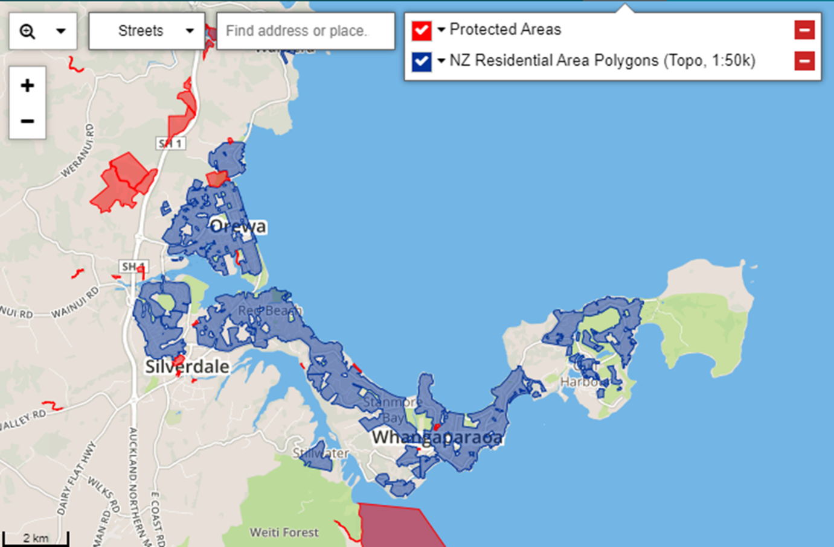

FIG. 1

This results in the following 4 target franchise areas shortlisted for further analysis.

1. Orewa
2. Silverdale
3. Stanmore Bay
4. Gulf Harbour

The map in figure 2a and its legend in figure 2b[13] below show even greater detail and includes Auckland zoning plans for the area. Please note that the yellow areas shown as Residential – Large Lot Zone in figure 2 are shown as blank in figure 1. Like other residential areas in figure 1 the yellow areas in figure 2 are also not zoned for commercial activities.

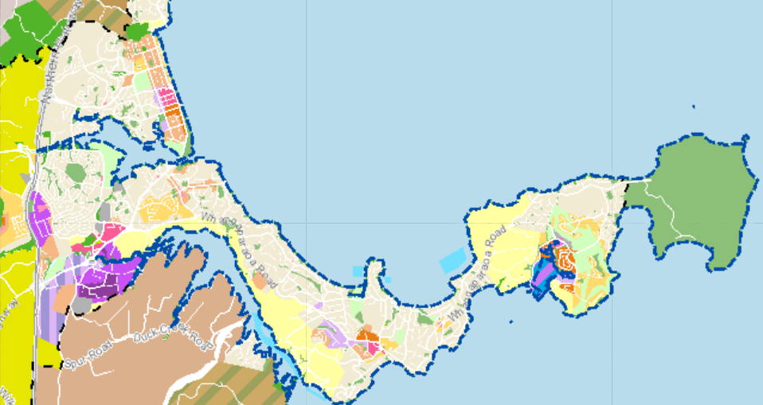

1. Orewa

2. Silverdale

3. Stanmore Bay

4. Gulf Harbour

FIG 2a

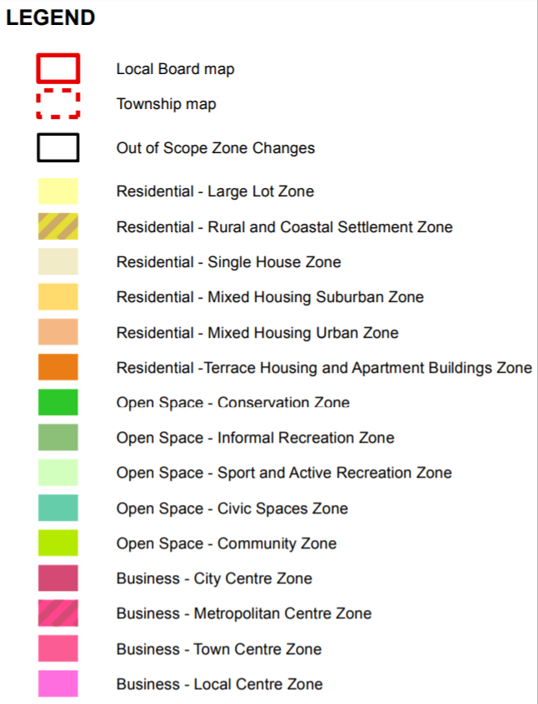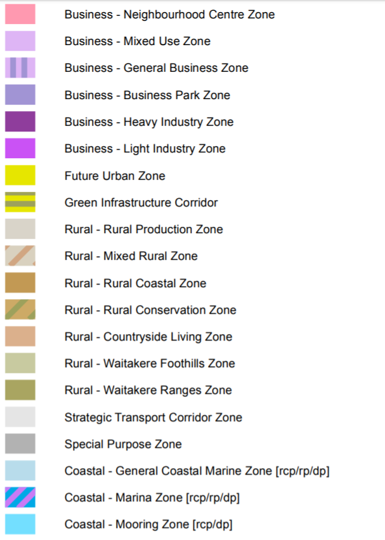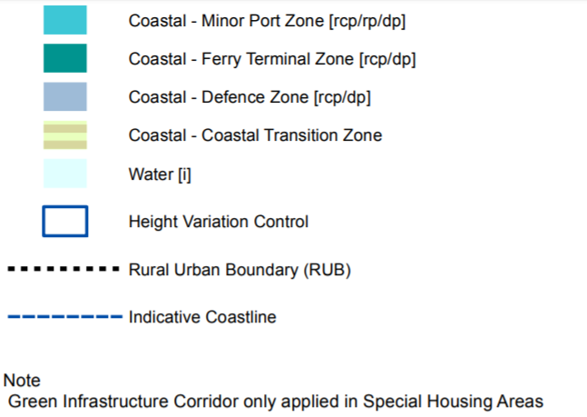

FIG 2b

# Eliminating Areas that Do not Comply with Franchise Requirements[14]

Based on franchise requirements, areas within 1.5 miles of the existing the fast-food franchise will be excluded. Given that there is an existing the fast-food franchise at Silverdale, this neighbourhood will be removed from the selection.

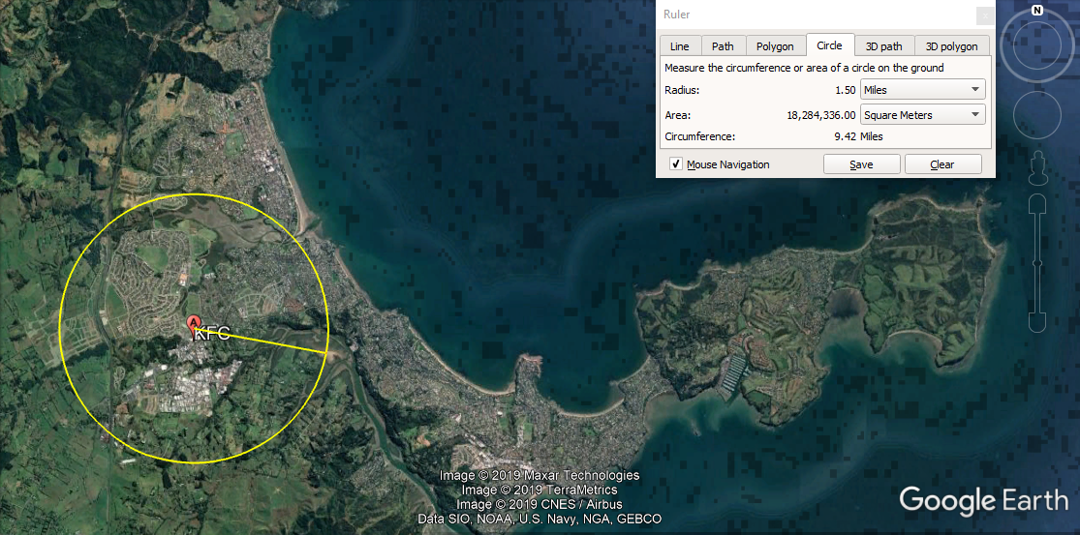

FIG 3

Please note that, while the service area of the fast-food franchise Silverdale overlaps with the service area of a potential the fast-food franchise located in the middle of Orewa’s commercial area, they are more than 1.5 miles apart. Other nearby franchises also overlap but are at least 1.5 miles from each other. These are:

* the fast-food franchise Glenfield and the fast-food franchise Birkenhead (approximately 1.95 miles apart)
* the fast-food franchise Albany and the fast-food franchise Windsor Park (approximately 2.21 miles apart)

The above assessment results in 3 target franchise areas shortlisted for further analysis shown below as well as shown in figures 4, 4a, 4b and 4c:

1. Orewa
2. Stanmore Bay
3. Gulf Harbour

FIG 4



1. Orewa

2. Stanmore Bay

3. Gulf Harbour



Shown in figure 4a, 4b and 4c below are maps of each of the three target areas focusing on the zones for commercial use.

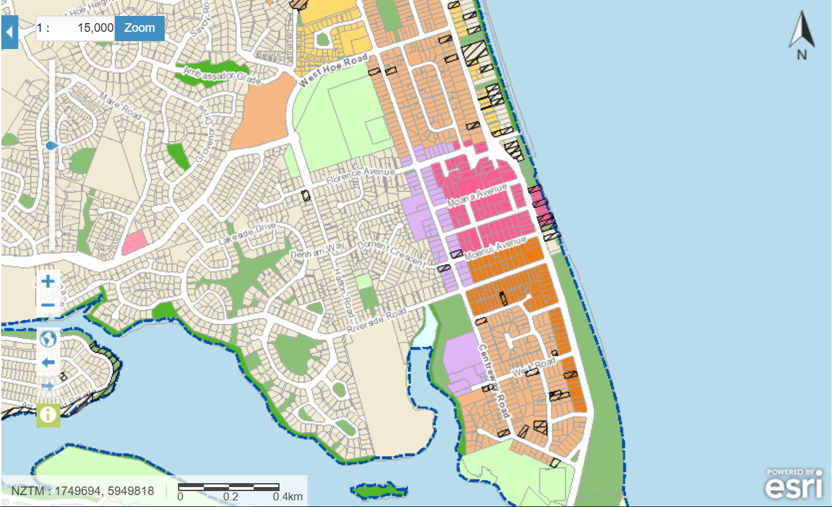

FIG 4a (OREWA)

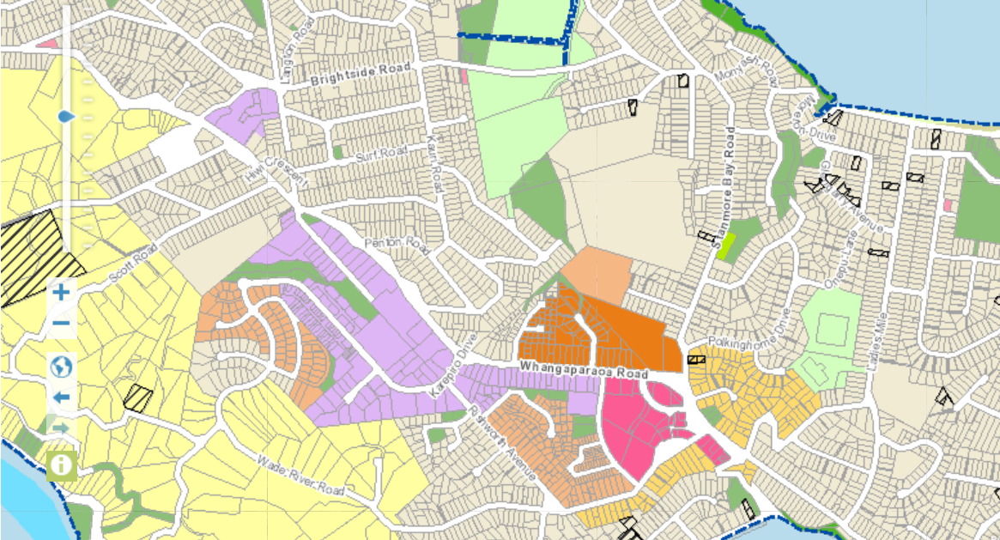

FIG 4b (STANMORE BAY)

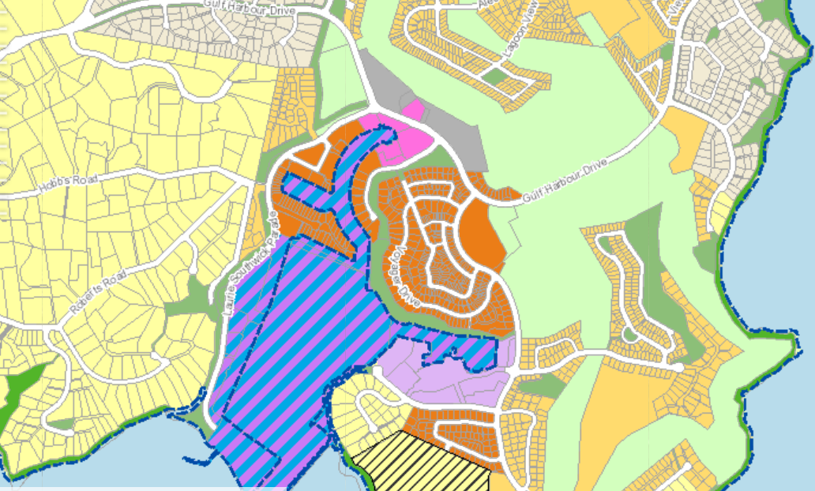

FIG 4c (GULF HARBOUR)

# Battle of the Neighbourhoods

The three shortlisted target franchise areas will be compared based on available demographics with respect to the target customer.

# Age Bracket

Based on recent New Zealand the fast-food franchise advertisements, the fast-food franchise target demographics according to age is determined as youth and young adults. Several definitions of ‘youth’[15] and ‘young adults’[16] can be found in major international organizations but these appear to change even within the same organization such as the United Nations. For the purposes of this study, the age bracket used will be the same as those used by New Zealand statistics[17] which are:

* 0-15 years old to represent youth and children
* 15-29 years old to represent young adults

It should be noted that while New Zealand statistics did not specifically mention youth, children nor young adults, the age brackets appear to adequately fit the fast-food franchise NZ commercial models found in their advertisements.

To determine the demographics by age within our target areas the analyst turns to an interactive webpage provided by the previously mentioned New Zealand statistics[18] to ensure consistency. While the webpage provides data that is necessary to the study, the way it is presented does not easily align to what is required in this study. This is explained in the following subsection.

**CHALLENGES:** First, while the source data provides useful suburban mapping and demographic data by age, it is not structured to be Python friendly. For this study, the analyst, individually inputs this data into a table. Also, while the preferred demographic data consist of the number of people of target age within 1.5-mile radius, unfortunately, the available data only shows the target demographic with SA2 section which is one level smaller than a suburb. To overcome this limitation, each SA2 section visually observed to have over 50% of its area inside the 1.5-mile radius from the target commercial centre is included as part of the target franchise areas. Areas outside are excluded. Also, since census only up to 2018 is available, the study used linear regression to predict the values in 2020.

Suburb division within the target franchise areas included in this study are those that have most of their areas within the 1.5-mile radius of the centre of the area’s commercial space. These are the following

* Orewa (Orewa Central, Hatfields Beach, Wainui-Waiwera, Orewa North and Orewa South)
* Stanmore Bay (Whangaparoa Central, Stanmmore Bay West, Stanmore Bay East, Manly West, Manly East, Okura Bush and Vipond)
* Gulf Harbour (Gulf Harbour South, Army Bay, Gulf Harbour North and Tindalls-Matakatia)

Shown in Figure 5 are the population below 29 years old within each of the target areas.

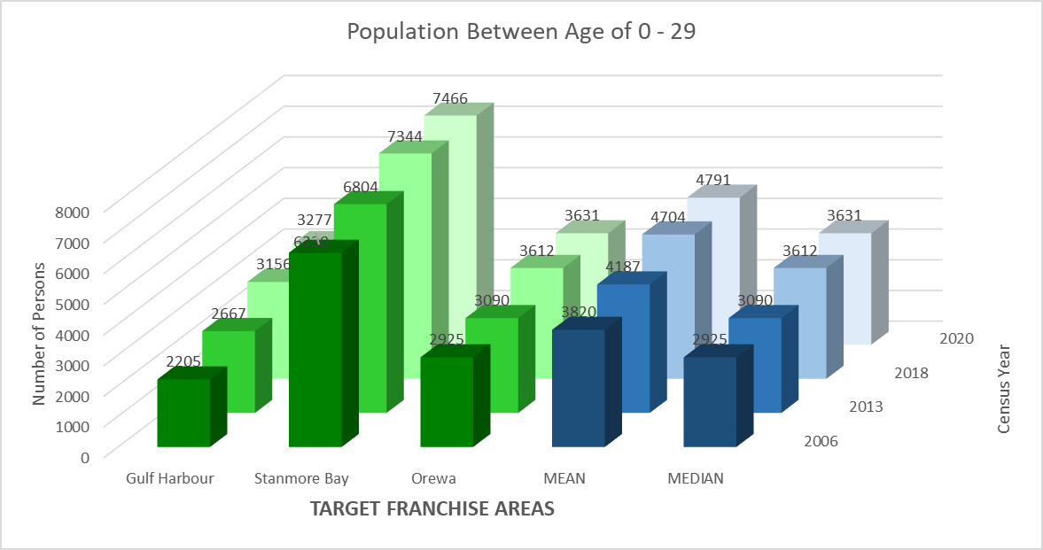

FIG 5

The chart and table consist of the sum of the population with age brackets 0 – 15 years old and 15 – 29 years old at the available census year 2006, 2013 and 2018. Year 2020 has been predicted using linear regression. All other age brackets are disregarded.

**INSIGHT:** The data shows that the Stanmore Bay area within the 1.5-mile radius has almost double the numbers than those found at Orewa and Gulf Harbour. Furthermore, in Figure 2, although Orewa area is shown to overlap with the existing Silverdale franchise and are expected to eventually share part of each other’s customers in that area, in figure 5 and 6, the number of individuals within the target age in the overlapping area South of the river is allocated to Silverdale rather than share to show how many new target customers Orewa can add to the existing the fast-food franchise customers. It also shows that the target population at all three areas are increasing at a steady growth rate between census years. While it may be possible that Stanmore bay has the largest target market, age wise because of what looked like more residential properties in the area compared to the others. This can only be confirmed by determining what number of properties in the area are residential properties and what number of persons of target age occupy each residential property. Such population may have arrived in the area for a variety of reasons such as lower house prices or rent, available jobs or a chosen lifestyle, however this is beyond the scope of this study.

Among the three target areas (Orewa, Stanmore Bay and Gulf Harbour), while Stanmore Bay shows that it has the market base according to age, it does not automatically mean that this is large enough to sustain a franchise outlet. One way to determine this is to compare the population of target age in areas that already have an existing franchise outlet. This way, we can determine whether the market base of the three target areas have the same potential as the areas that have existing franchise outlets or whether they are not big enough to warrant a franchise outlet.

**CHALLENGES:** Selecting areas for benchmarking is not straightforward. Current franchise areas at the centre of Auckland have denser populations compared to the three target areas which are located at the Northern edge of Auckland. Such comparison will skew the baseline. There are also more competing franchise outlets at the centre of Auckland as well as activities that may distract or attract potential outlet patrons therefore showing a mismatch in customer behaviours. Current franchise areas selected to benchmark are chosen based on their similarities to the three target areas.

Market base according to age of shortlisted target areas compared with existing the fast-food franchise areas are shown in the graph in figure 6 below. Unlike the shortlisted area, each of the existing the fast-food franchise suburbs include SA2 sections with most of their areas within 1.5 miles of the the fast-food franchise fast-food restaurant. Also, these are chosen as benchmark because, similar to our shortlisted target franchise areas (Gulf Harbour, Stanmore Bay and Orewa), they are located at or near the outskirts of Auckland City and will therefore have similar suburb population densities and characteristics.

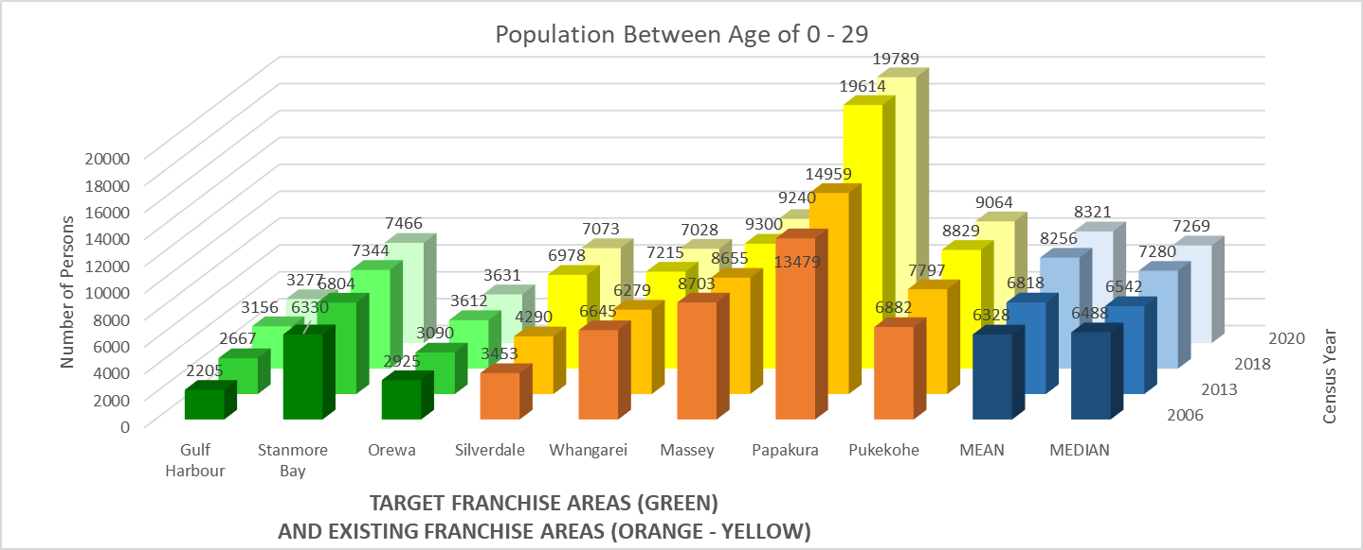

FIG 6

**INSIGHT:** As shown in Figure 6, the target franchise areas are in four shades of green while the suburbs with existing the fast-food franchise stores are shown in orange – yellow (These are the benchmarks). Mean and median are shown in blue. The target the fast-food franchise customer population (0 – 29 years old) for both Gulf Harbour and Orewa areas represent the lowest two out of the 8 areas in the 2018 census and are projected to be so in 2020. This is understandable, given that a large part of the two areas consist of the sea and not residential properties as shown in Figure 4. Stanmore Bay on the other hand compares well by being 4th among the 8 areas (after Papakura, Pukekohe and Massey in the 2018 census) despite part of its radius also made up of sea. This may indicate a comparatively dense population of people less than 29 years old. Unfortunately, this also meant that future growth of Stanmore bay’s market base depends on development of smaller areas (compared to those of the benchmarks), construction of high-rise apartments and more individuals packed into existing and likely, rental properties.

Silverdale, a suburb with an existing the fast-food franchise, is geographically closest to the three and therefore provides the most similar area to compare. The graph shows that it has the most significant increase between the 2013 and 2018 census. Although it appears that a major housing construction at Millwater[19] following a commercial construction boom in the area caused this increase, this can be confirmed by determining whether this translated to an increase in occupied residential property and the number of occupants. Even so, Millwater still has less market base than does Stanmore Bay. Papakura appear to be out of place and its target population is twice as large as the next largest franchise area. This is explained by the size of its residential area as well as its density. However, Papakura is still included among the benchmarks because it is also located at Auckland’s Southern outskirts.

# Income Bracket

As of June 2019, the median New Zealand weekly income[20] from wages and salaries is NZ$ 1,016. This translates to just over NZ $52000 per person per year. For the purposes of this study, the median salary in 2018 is NZ$ 50,000. Given the target customer is low to middle income, their bracket shall be between NZ$ 0 to NZ$ 50,000 per year. Below is a collection of data from Statistics New Zealand focusing on the percentage of the population >15 years old with income of less than NZ$ 50,000 per year. This is based on the available 2001, 2006 and 2013 data[21]. 2018 and 2020 income are predicted through linear regression. Where data is not available, the income data of the nearest suburb division or the average of the surrounding suburb divisions is used.

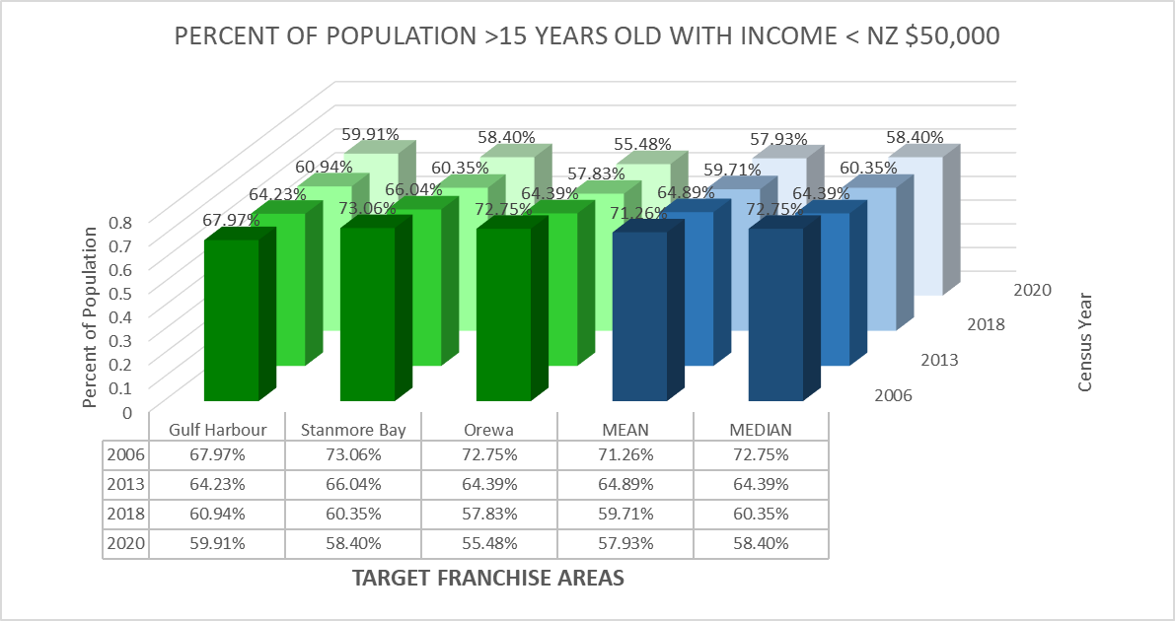

FIG 7

**INSIGHT:** Among the three 1.5-mile radius areas for target franchise areas, Stanmore Bay[22] started in 2006 as the highest percentage of individuals with salaries less than NZ$ 50,000 at roughly 73% followed closely by Orewa and then Gulf Harbour. This meant that income bracket wise, in 2006 a higher percentage of individuals at Stanmore Bay and Orewa than at Gulf Harbour are within the franchise target customers. Projecting 2006 and 2013 available data through linear regression to 2018 and 2020 shows that, Gulf Harbour has become the area with the highest percentage of individuals with salaries <$ 50,000 followed closely by Stanmore Bay and then lastly by Orewa. The data shows that while all three areas are becoming more affluent (percentage of people >NZ$ 50,000), the Orewa area is doing so at a faster clip thereby shifting more of its residents out of the franchise target customer, income wise, than the other two. A few causes for the increase in average income can be a combination of the following:

* Increase in income of existing residents
* Higher income of incoming residents
* Residents coming out of retirement
* Residents with lower income leaving the area including through death
* Jobless residents finding jobs with salary >$50,000
* Jobless residents leaving the area

Below is a graph showing the percentage of the population >15 years old with income of less than NZ$ 50,000 per year for suburbs for target franchise area (green) and suburbs with existing franchise area(orange).

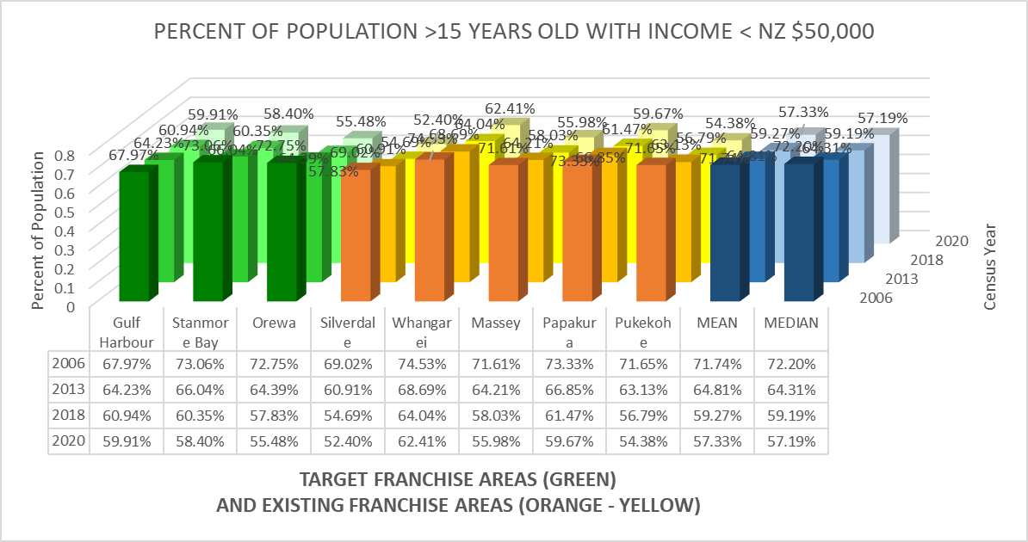

FIG 8

**INSIGHT:** In 2006, Stanmore Bay, Orewa, Whangarei, Massey, Papakura and Pukekohe are all in a narrow band of percentage of individuals > 15 years old with less than NZ $ 50,000 yearly income at between 70% - 80%. Two of them, Gulf Harbour and Silverdale were between the range 60%-70%. In 2006, Whangarei, Stanmore Bay and Papakura have the highest percentage of target customers, income wise. On the other hand, Gulf Harbour has the least percentage followed closely by Silverdale. It meant that Gulf Harbour and Silverdale appear to be most affluent areas in 2006 and therefore least ideal for a franchise location, income wise. Projecting the data through linear regression in 2018 and 2020 shows that all areas have become more affluent because the percentage of >15-year-old with <$ 50,000 salary has steadily dropped. In 2018, the projection shows that there are none of the areas are in the 70% to 80% range and four (Orewa, Silverdale, Massey and Pukekohe) are now in the 50% - 60% range. In the 2020 projection, all of the areas save for Whangarei are in the 50% - 60% range. Interestingly, the income projection to 2020 shows that Whangarei, Gulf Harbour, Papakura and Stanmore Bay, in that order, appear to have the highest percentage of residents with < $50,000 income. All three except, Gulf Harbour, appear to be consistent in this regard because Gulf Harbour previously has among the lowest percentage. The 2020 projection shows that Silverdale has the lowest percentage of individuals >$ 50,000 followed closely by Pukekohe, Orewa, and Massey. All four are increasingly shifting their residents outside the franchise income bracket at a fast clip.

# Combined Income and Age Bracket

**CHALLENGES:** Combining the income and age data is not so straightforward as multiplying both data since they do not seamlessly align. For instance, the available demographics data based on income goes homogenously across all age brackets above the age of 15 on any given area while the demographics data based on age has greater granularity. As for individuals <15 years old not represented by the income data, it is assumed in this study that those individuals are either offspring or are looked after by individuals that are >15 years old who would take them to the fast-food outlet rather than individuals <15 years old going there by themselves. This study thus assumes that people with percentage of income <$50,000 is homogeneous across all age brackets simply because this the only available data. In truth, this is not the case as individuals tend to earn more as they gain more job experience.

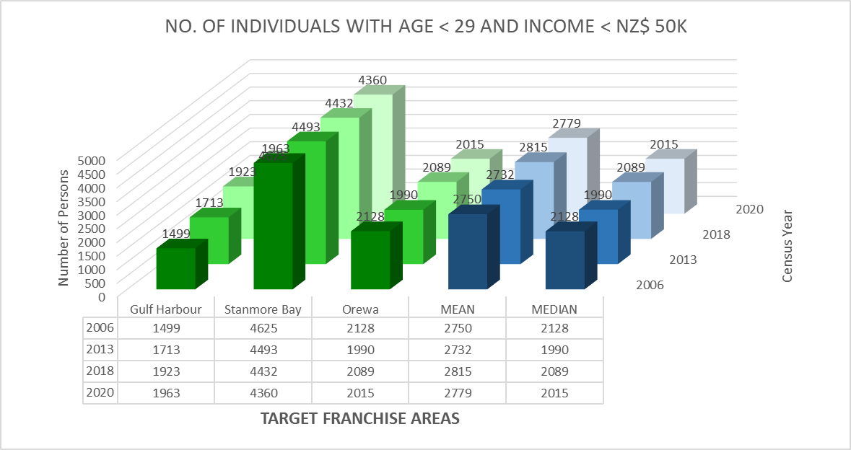

FIG 9

**INSIGHT:** The combined data shows that while Gulf Harbour has the lowest number of target customers in terms of the combined age and income bracket, that same data shows that this number is steadily increasing. Apparently, the slow increase in income and the steady increase in the population of <29-year olds has contributed to this upward trend. Orewa on the other hand has the second largest number of target customers. However, this has decreased between the census year 2006 and 2013 but is shown to recover between 2013 and 2018 owing to the increased number of individuals >29 years old more than offsetting the rising income in the area. Unfortunately, the number of target customers is predicted to decrease in 2020. Stanmore Bay on the other hand has the greatest number of target customers, unfortunately this is decreasing. This is due to the increase in annual salary of people in the area outstripping the number of individuals of target age thereby pushing potential customers outside the target income bracket.

The graph in figure 10 below shows the number of target customers with the same three target franchise area compared with areas that have existing the fast-food franchise outlets using both age and income data.

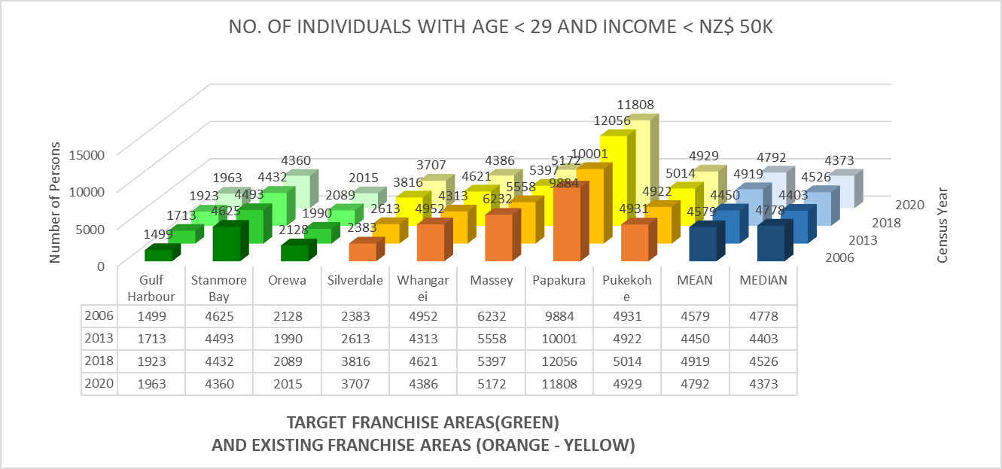

FIG 10

**INSIGHT:** Papakura is shown to still have the greatest number of target customers in the area when it comes to both age and income. Gulf Harbour is again shown to have the least number of target customers. Among the suburbs, only Papakura, Gulf Harbour and Silverdale have steadily increased but for different reasons. Of these Papakura and Silverdale are forecast to decrease between 2018 and 2020. Gulf Harbour increased because even though its target age population growth is comparatively slow, its income growth is even slower thereby retaining more of the population in the target income bracket. Papakura and Silverdale on the other hand increased steadily because their explosive population growth has overcome their growth in income. It is only in 2020 that income growth has finally caught up with target age population growth, resulting in a decrease. One possible factor that may contribute to Silverdale’s income growth was the recent commercial construction boom in the area but at the same time, the residential construction that followed may have contributed to the population surge. Orewa, Whangarei and Pukekohe are observed to have rolling target demographic due to the interaction of population and income growth in their respective areas. Only Stanmore Bay and Massey are shown to consistently decrease through the three census years plus the forecasted year. This is caused by the income growth in the area consistently outstripping the target population growth with respect to age. In hindsight, the more affluent an area becomes, the more the target customers get pushed out of the target income bracket this can only be offset by a comparative growth in target age population.

# Effect of Geography

While geography is likely to affect the eating habits of target customers because of natural barriers and proximity of the nearest franchise outlet, the effect of the terrain at Hibiscus and Bays area on the customer is more pronounced because the three target franchise areas (Orewa, Stanmore Bay and Gulf Harbour) and one area with existing the fast-food franchise outlet (Silverdale) are located on a peninsula. Sea from both sides of the peninsula act us a major natural barrier. Gulf Harbour Ferry is the only other public transport available to Auckland City without going through to the Peninsula. However, for simplicity and for the purpose of this section of the study, several assumptions will be made:

* The effect of marine routes outside the peninsula is assumed to be insignificant. This is because the number of customers who travels 30 km to the city for the fast-food franchise or other fast food using the ferry is relatively small given that they can travel half that distance to a franchise outlet located at Silverdale. The closest competing fast food competitor is 7 km away at Stanmore bay.
* Although the customers’ buying behaviour are affected negatively by their distance[23] to a franchise outlet, it will not be computed given there is no publicly available empirical data showing to what extent potential customers frequency of patronizing an outlet declines because of the distance.
* Instead, since only one of the target areas is chosen as location of a new franchise, it will be assumed that customers from the other areas will patronize the next closest franchise outlet.

Each of the target areas will be shown below with their updated number of target customers because of the effects of geography.

# Orewa

As shown in figure 11 below, the target demographics at both Gulf Harbour and Stanmore Bay areas are assumed to equally patronize the existing outlet at Silverdale and a target franchise outlet at Orewa. This means that in our succeeding graph, the sum of their target demographics will be divided equally and then added to the target demographics at Orewa and at Silverdale.

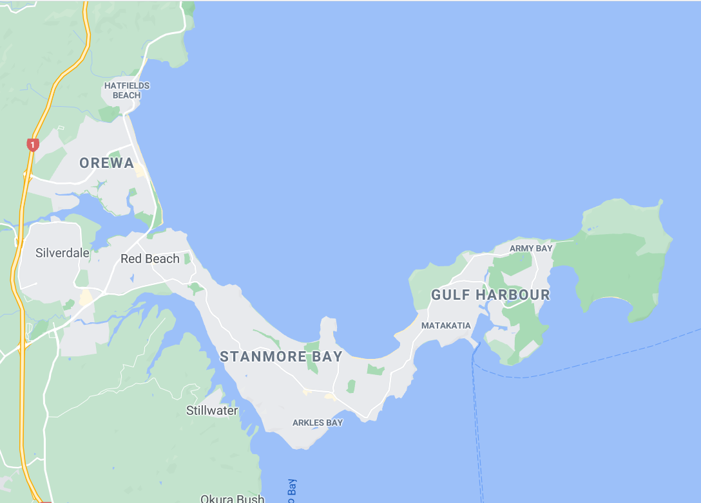

Orewa

Silverdale

Stanmore Bay

Gulf Harbour

FIG 11

The resulting graph is shown below.

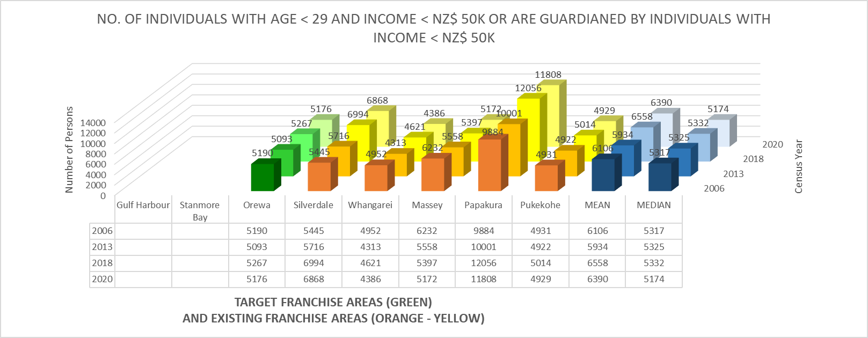

FIG 12

Unfortunately, potential customers traveling through Stanmore Bay’s commercial centre may be lost to competitors. This results in the values for both Orewa and Silverdale to be lower than that shown in the graph. For this analysis, however, the numbers shown in the graph will be used since there is no available empirical data that shows to what extent potential customers will be lost to competitors.

# Stanmore Bay

As shown in figure 13 below, existing Gulf Harbour target customers will be absorbed by a potential Stanmore Bay franchise outlet because the main highway passes through Stanmore Bay’s commercial area before even reaching Silverdale. Meanwhile all the target customers at Orewa will be absorbed by the existing Silverdale franchise because of proximity.



Orewa

Silverdale

Stanmore Bay

Gulf Harbour

FIG 13

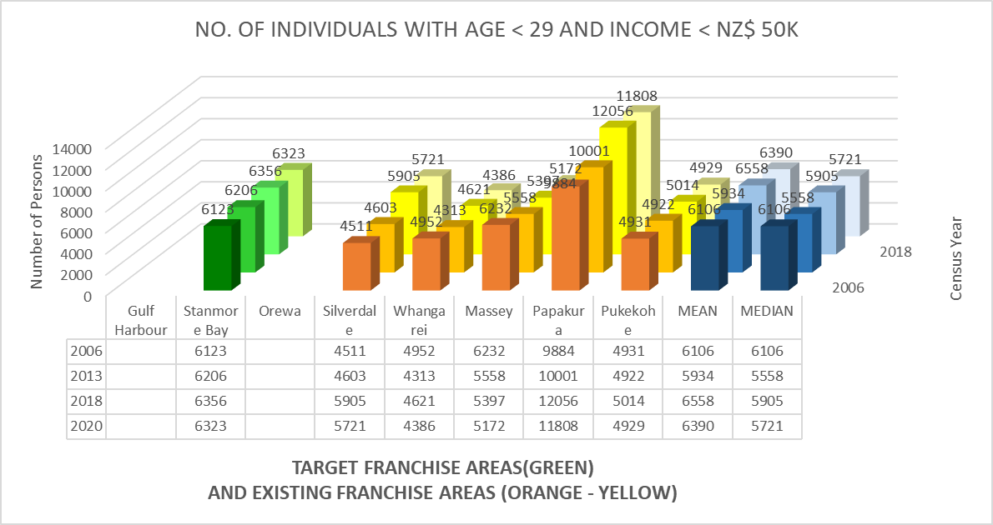

FIG 14

Similarly, potential customers can be lost to competition at Orewa’s and Gulf Harbour’s commercial centres. This results in the numbers also being lower than that shown in the graph. However, the value shown in the graph will be used in the analysis, for the same reason as that used for Orewa.

# Gulf Harbour

As shown in Figure 15 below, the target customers on the Eastern half of Stanmore Bay will be absorbed by a potential Gulf Harbour franchise while the Western half of Stanmore Bay will be absorbed by Silverdale. Also, Silverdale will handle all target customers in the Orewa area.



Orewa

Silverdale

Stanmore Bay

Gulf Harbour

FIG 15

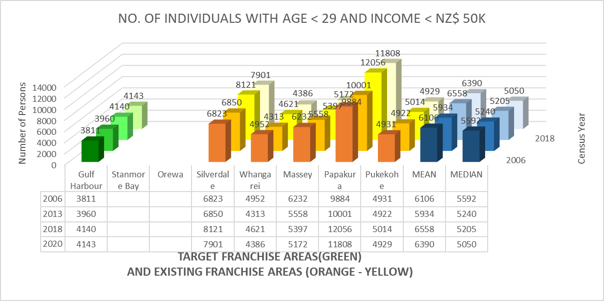

FIG 16

Like the first two, potential customers can be lost to competition at Orewa’s and Stanmore bay’s commercial centres. This results in the numbers being lower than that shown in the graph. However, the value shown in the graph will be used in the analysis, for the same reason as that used for the first two areas.

# DISTRICT COMPARATIVE ADVANTAGE

The previous section shows that the size of the fast-food franchise’s target demographics in Stanmore Bay is comparable to the fast-food franchise’s existing markets in similar areas. However, it is important to consider whether the food services industry in Stanmore Bay is comparably competitive to the same existing markets. This will establish not only whether the target market will patronize the new fast food outlet but will give an indication of the area’s competitive advantage.

This website[24] defines competitive advantage as *“*A high concentration of certain industries in an area can be indicative of the area having a comparative advantage in these industries. This comparative advantage may be a result of the area’s natural endowments, location, skill profile, or other reasons.

This section uses location quotients to identify what industries an area may have a comparative advantage in. An area has a location quotient larger than one when the share of that industry in the area’s economy is greater than the share of the same industry in the national economy.”

**Challenge:** Unfortunately, the available data does not provide the level of granularity that was available in the previous section such that these are available in the district area level and not the previous suburb level. For example, all the candidate areas (Orewa, Stanmore Bay and Gulf Harbour suburbs) are grouped into the Hibiscus Bays Area. Fortunately, our benchmark suburbs are far enough apart that they are in different districts. The analyst finds this data sufficient for its purpose.

Figure 17 below, shows the Location Quotient of each district with respect to the industry “Accomodation and Food Services Industry”

FIG 17

Figure 18 below, shows the size of the accommodation and food services industry with respect to the total GDP.

FIG 18

Lastly, Figure 19 shows the percent share of total growth that the accommodation and services industry have, compared to the areas total GDP growth between 2018 and 2019.

FIG 19

The above data establishes that the Hibiscus and Bays accommodation and food services industry and by extension Stanmore Bay’s industry is as competitive as, if not more so than comparable the fast-food franchise market.

# INSIGHT AND CHOICE OF LOCATION

Stanmore Bay is chosen as the best franchise location among the three because of the following:

* Among the three, Stanmore Bay draws the most target demographics based on government census, statistics data, and geography.
* The size of its target demographics is greater than the average of comparable areas with existing franchise. The size of Papakura’s target demographic has raised the mean to just slightly above those of Stanmore Bay.
* Stanmore Bay is situated where the bulk of the target customers in Hibiscus and Bays are located. Proximity of the proposed outlet will make it easier for the customers to visit it and could likely translate to actual store visits than if it is located further.
* Hibiscus and Bays accommodation and food services industry and by extension Stanmore Bay’s food and services industry is more advantageous than comparable the fast-food franchise markets in Auckland.

While most of Stanmore Bay’s target demographics are within the suburb, those living at Gulf Harbour complements it by providing the growth in target customers. For comparison, should Orewa be chosen as the next franchise, most of its target customers are located further away at Stanmore Bay and Gulf Harbour area which will be negatively affected by the distance. Gulf Harbour on the other hand has the least number of target demographics because it will split the those from Stanmore Bay equally with the existing Silverdale franchise. Also, the number of target customers at Orewa is significantly less than the mean and median.

# STANMORE BAY

Stanmore Bay[25], comprising the statistical areas of Vipond, Whangaparoa Central, Stanmore Bay West and Stanmore Bay East, had a population of 12,165 at the [2018 New Zealand census](https://en.wikipedia.org/wiki/2018_New_Zealand_census), an increase of 1,059 people (9.5%) since the [2013 census](https://en.wikipedia.org/wiki/2013_New_Zealand_census), and an increase of 2,001 people (19.7%) since the [2006 census](https://en.wikipedia.org/wiki/2006_New_Zealand_census). There were 4,401 households. There were 5,976 males and 6,198 females, giving a sex ratio of 0.96 males per female, with 2,424 people (19.9%) aged under 15 years, 2,340 (19.2%) aged 15 to 29, 5,598 (46.0%) aged 30 to 64, and 1,800 (14.8%) aged 65 or older.

Ethnicities were 88.7% European/Pākehā, 10.6% Māori, 2.8% Pacific peoples, 7.2% Asian, and 2.3% other ethnicities (totals add to more than 100% since people could identify with multiple ethnicities).

The proportion of people born overseas was 28.7%, compared with 27.1% nationally.

Although some people objected to giving their religion, 54.1% had no religion, 34.5% were Christian, and 4.4% had other religions.

Of those at least 15 years old, 2,070 (21.3%) people had a bachelor or higher degree, and 1,458 (15.0%) people had no formal qualifications. The employment status of those at least 15 was that 5,160 (53.0%) people were employed full-time, 1,485 (15.2%) were part-time, and 300 (3.1%) were unemployed

Shown in figure 20 below is a more detailed map of Stanmore Bay and Gulf Harbour. Essentially this is where the target customers of a proposed Stanmore Bay franchise reside.

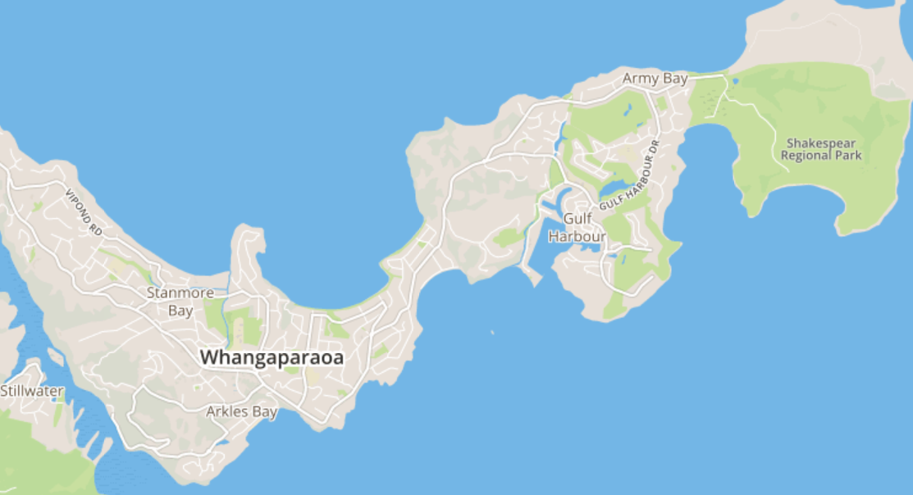

FIG 20

Looking closer at Stanmore Bay, the commercial areas based on council zoning requirements are identified and marked in red. This way, large areas will be removed from further analysis and only specific areas will now be considered for the location of a fast food outlet



FIG 21

Out of the areas allotted for commercial activity, seven (7) commercial leasable space from online advertisements are available and summarized in Fig 22 below. Of these, three (3) shown as items 5, 6 and 7 in the table are classified as office and retail space and are deemed facilities that are not appropriate for commercial food service. One (1) shown as item 5 is only 50 square meters and deemed too small to serve the potential number of patrons as well as for future growth.



FIG 22

# Factors to Consider

For this study, the factors in selecting the potential franchise outlet are limited to four factors shown below.

# Visibility and Accessibility[26]

Store visibility is a primary factor that attracts customers to visit your outlet. Therefore, it is important to choose a location that grants the best visibility for the budget you have set out. There are a variety of factors that define the visibility of a store: level, escalator facing, nearby toilet, area tenant mix and more.

Businesses situated near transport points naturally invite more foot traffic and are more visible. Malls and shops that are typically beside or close to MRT stations or bus terminals enjoy greater foot traffic from different customer segments, especially during peak hours.

# Security[27]

The franchise location can increase the odds of being affected by crime, which in turn can influence your insurance premiums, as well as the additional security measures you made need to take to keep your premises safe. Knowing the risks of potential criminal activity can help you better prepare and take adequate precautions.

# Parking[28]

Drivers make up a considerable amount of traffic when it comes to accessibility. Locations that attract a high concentration of drivers are usually locations with reasonable parking rates, ample parking spaces, and easy to access parking areas. With these defining attributes, the location has greater potential to attract family groups and office lunch crowds.

# Competition[29]

Your proximity to other competing businesses could be crucial to your success. Could they provide a benefit to your business or cause a hindrance? Establishing which competitors are in your area and their offering could help guarantee you choose the right location for your business. If there is too much competition, then it may be a warning sign to expand your horizons to a new location. There are exceptions to this such as car dealerships who want to be near each other as customers compare and choose the best car deal, hence their proximity. Likewise, if you have an element of your offering that is unique or offers some kind of new innovation, then choosing an area that already has a ripe market could be the ideal way to pick up customers very quickly and establish a presence in a new area in a relatively short time frame.

# Three Shortlisted Candidates

# OPTION 1:

# 719 Whangaparaoa Road, Stanmore Bay, Auckland, New Zealand 0930

Otherwise known as the Coast Plaza. This mall has an internal refresh underway. The stages of redevelopment will include a transformation of the courtyard to provide the community with a dining precinct bringing a flow from the indoor out, making Coast Plaza both a shopping destination and a meeting place. [30]

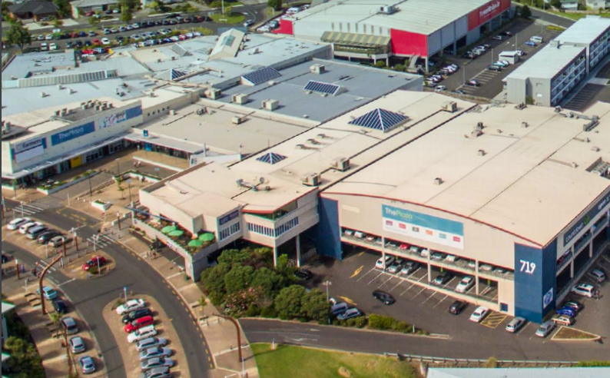

FIG 23

The arrow points to the probable location of the courtyard that will be transformed to a dining precinct mentioned by the advertisement. This can be confirmed through the advertisers referenced in this study. There is an entrance to the upper right corner of the courtyard which flows straight into a major supermarket. A large covered parking area is available to the right as well as in the middle of the road fronting the courtyard.

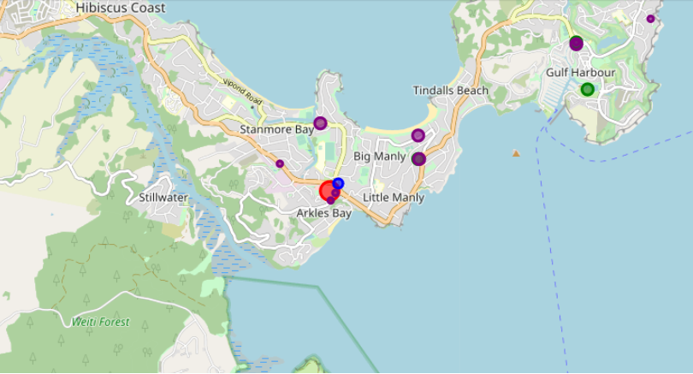

FIG 24

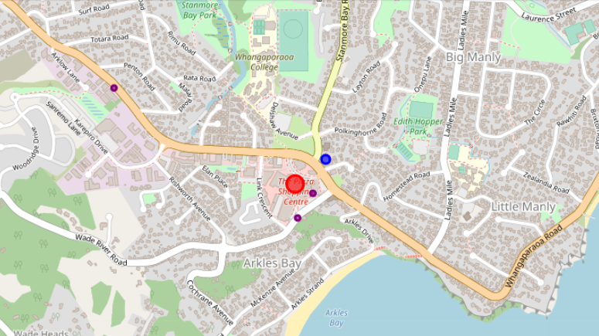

FIG 25

# Visibility and Accessibility – The location is at the centre of gravity of the community commercial centre. It is at a courtyard at one of two main entrances to the mall. This entrance goes straight to a major supermarket. The mall courtyard is right across the community library. Frequent and steady foot traffic is expected. In terms of visibility, it does not get better than this at Stanmore Bay.

# Security – The location is around 200m from a police station. This is marked blue in the map.

# Parking – Ample parking is available from both the covered mall parking area and roadside parking.

# Competition – There are more coffee shops and restaurants than that revealed by Foursquare. However, the fast food outlet is the only one that specializes in fried chicken. The advantage is that the competition attracts patrons that are looking for food. The disadvantage is that patrons may be attracted to competing establishments that offer food.

# OPTION 2:

# 5A/667 Whangaparaoa Road, Whangaparaoa, Auckland 0930

Large retail with fantastic exposure to Whangaparaoa main road. 210m2 building area with own amenities and shared customer car parking directly in front of glazed shop entrance. Currently set up as hospitality however would also be suitable as retail or office premises. [31]

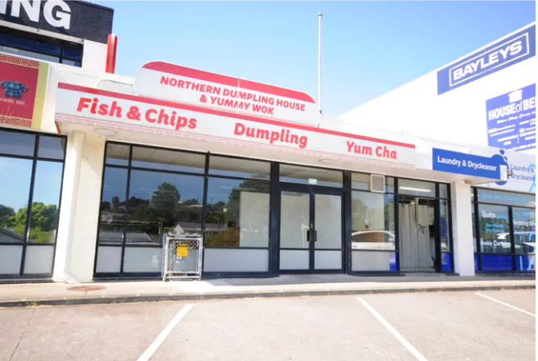

FIG 26

Parking area is available at the front of the property but will have to be shared with the other tenants.

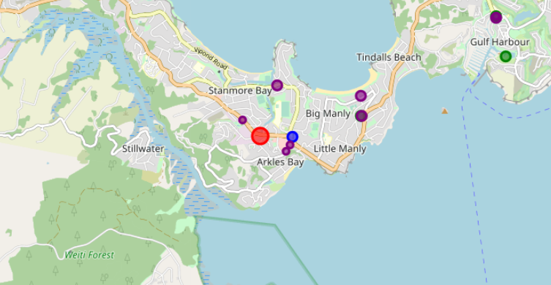

FIG 27

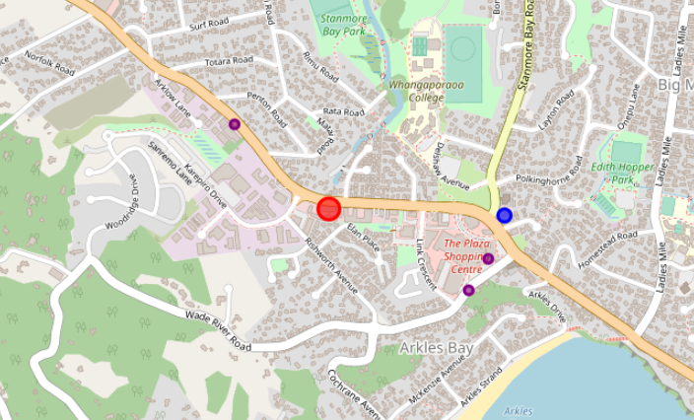

FIG 28

# Visibility and Accessibility – The location is very visible from people riding and driving along the main road. It is part of a cluster of commercial establishments along the highway.

# Security – The location is around 700m from the nearest police station

# Parking – There are available parking slots right in front of the building, but these are shared with the other tenants.

# Competition – There are some food establishments in the same building that Foursquare have not shown. The advantage is that there may be less competition. The negative is that the location may not generate adequate attraction to people looking for foord.

# OPTION 3:

7/15 Karepiro Drive, Stanmore Bay, Auckland 0930

This modern retail unit would suit a wide range of businesses. Businesses can also take full advantage of the heavy foot traffic that has been derived from the surrounding quality tenants, accompanied with the excellent signage opportunities facing Whangaparaoa Road. [32]

Features include

Floor area 82sqm (approximately)

Ample shared parking

Dual entrance into unit

Floor to ceiling glass facade

Excellent signage opportunities

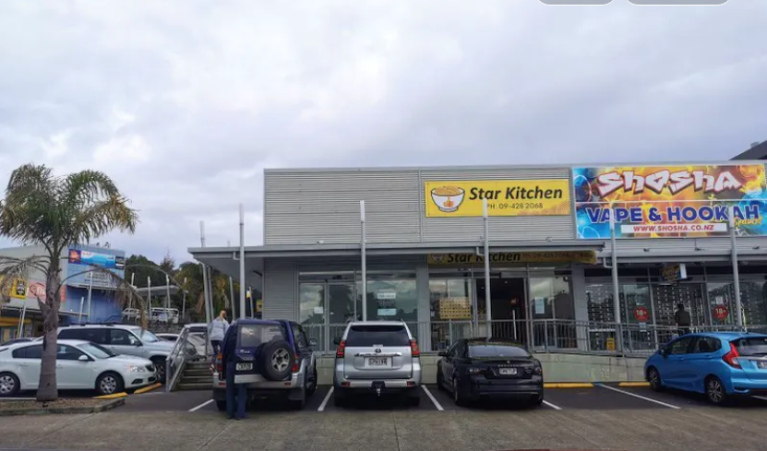

FIG 29

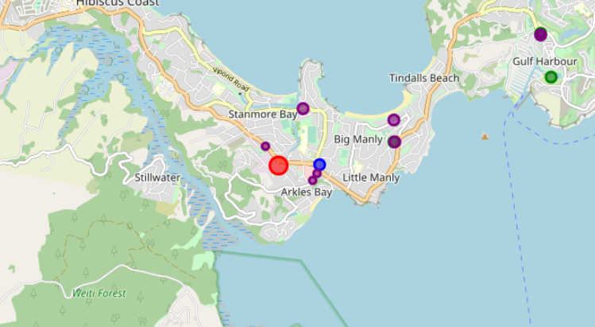

FIG 30

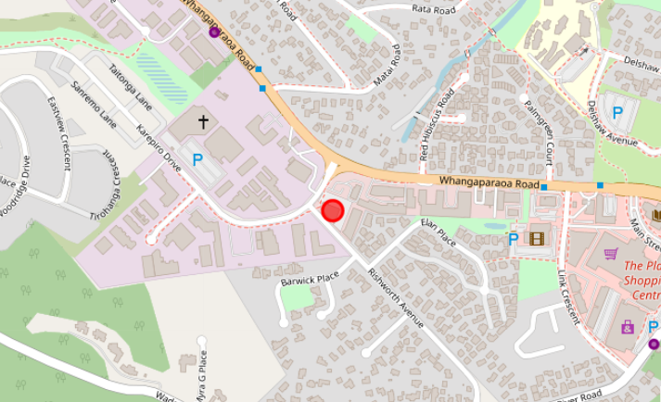

FIG 31

# Visibility and Accessibility – While the building is not directly fronting the road, it is visible from it. There is a fruit market and a clinical laboratory within the compound.

# Security – The location is around 900m from the nearest police station.

# Parking – There are available parking space around the compound, but these are shared with the other tenants.

# Competition – Multiple food service establishments are available in the area. While this attracts patrons, who are looking for food, the competition pulls the people away from the potential fast food outlet.

# **CHALLENGES:**

Below is a list of some of the problems encountered in this section of the study.

* The coordinates provided by using nominatim in Python is not accurate for the candidates and at times more than a kilometre away from the actual location. In order not to ruin the result of the study, the actual coordinates are used for the candidates while retaining the option of using foursquare in other addresses.
* Some of the existing business entities do not show up in nominatim. New Zealand police in Stanmore bay has been manually added in the Python program while other businesses have been acknowledged.
* The term car park or parking lot resulted in recreational parks which will ruin the result of the study. Fortunately, photos of the candidates show nearby parking spaces. This is used in this study.

# RESULTS

The three candidates are compared based on the four criteria:

* Visibility and Accessibility
* Security
* Parking
* Competition

The candidates are ranked from first to third on each of the four criteria. The average of the four criteria for each of the three candidates are then calculated with the lowest score among them making the top of the selection.



Candidate 1 unanimously ranked first across the board and therefore selected as the location of the the fast-food franchise Franchise outlet.

# FINAL THOUGHTS

While candidate 1 is selected, it is by no means, perfect. It has one limitation which is to allow patrons the option of a drive through service. Ideally, a fast-food outlet allows the option of a drive through for those that do not have the luxury of time. The outlet at Silverdale is a standalone building fronting a nearby mall and near a commercial centre. This allows it to have a small route around the building for a drive through service.

At the beginning of the study, the analyst expected the outlet to come from somewhere in the Orewa commercial area because it is well established with a wide selection of dining options close to the beach. The analyst also preferred the outlet to come from the small commercial centre at Gulf Harbour because it is close to his home. However, the resulting selected outlet location at the Coast Plaza mall comes from objectively following the data.

The analyst has also observed that the fast food is losing numbers from its target demographics because the population has become more affluent and are pushed outside the fast food’s salary bracket. It may be prudent to expand the target demographic to include the next higher salary bracket.

1. See <http://www.restaurantbrands.co.nz/our-brands/> for information regarding Restaurant Brands
2. See https://ecoprofile.infometrics.co.nz/Hibiscus+and+Bays for information about the economic profile of Hibiscus Coast and Bays area.
3. See <https://www.educationcounts.govt.nz/find-school/schools?district=7602> for more information about the schools in Hibiscus Coast and Bays area.
4. See https://www.fsrmagazine.com/expert-takes/8-factors-choosing-new-restaurant-location
5. See https://totalfood.com/secrets-successful-site-selection-restaurant-tenants/
6. https://www.cdc.gov/pcd/issues/2015/15_0065.htm#:~:text=We%20identified%20513%20visits%20to,standard%20deviation%2C%203.7%20miles).
7. https://cdn2.hubspot.net/hubfs/263750/Access_Consumer_Spend_Study_2016.pdf
8. https://unitaryplanmaps.aucklandcouncil.govt.nz/upviewer/
9. See https://unitaryplan.aucklandcouncil.govt.nz/Pages/Plan/Book.aspx?exhibit=AucklandUnitaryPlan_Print for more information about Auckland Council zoning requirements.
10. See https://www.franchisedirect.com/foodfranchises/kfc-franchise-07095/ufoc/ for more information about franchise requirements.
11. See https://www.youtube.com/user/kfcnz/videos for more information on the fast-food franchise’s, New Zealand advertisements. Links on the abovementioned videos are found here (https://www.youtube.com/watch?v=2Z0O_F4xiwo, https://www.youtube.com/watch?v=46vMbcgQrho, https://www.youtube.com/watch?v=kEsk29AgTvk, https://www.youtube.com/watch?v=2hfJaa3MjhU, https://www.youtube.com/watch?v=h5jh7Mz-fzY)
12. See https://unitaryplan.aucklandcouncil.govt.nz/Pages/Plan/Book.aspx?exhibit=AucklandUnitaryPlan_Print for more information about Auckland Council zoning requirements.
13. See https://www.aucklandcouncil.govt.nz/plans-projects-policies-reports-bylaws/our-plans-strategies/unitary-plan/history-unitary-plan/docsrecommendationszoning/aupzoningmaphibiscusbayshibiscuscoast.pdf for more information about Auckland Council zoning requirements.
14. See https://www.franchisedirect.com/foodfranchises/kfc-franchise-07095/ufoc/ for more information about franchise requirements.
15. United Nations define ‘youth’ as between ages 15 – 24 years. Consequently, ‘children’ is defined as aged 14 and below. See https://www.un.org/development/desa/youth/what-we-do/faq.html for the answers to queries about the definition of youth and children.
16. New Zealand Justice define ‘young adults’ as between ages 15 – 29 years. See https://www.justice.govt.nz/justice-sector-policy/research-data/nzcass/survey-results/results-by-subject/young-adults/for the definition of young adults.
17. See http://statsnz.maps.arcgis.com/apps/MapSeries/index.html?appid=3fbdb156fd054beea5a62bdd2e596c6e for the age brackets used by New Zealand Statistics.
18. See http://statsnz.maps.arcgis.com/apps/MapSeries/index.html?appid=3fbdb156fd054beea5a62bdd2e596c6e for the age brackets used by New Zealand Statistics.
19. See https://www.stuff.co.nz/auckland/76784210/special-housing-area-in-north-auckland-continues-growth-spurt for news on the recent and continuing housing construction.
20. See https://www.stats.govt.nz/information-releases/labour-market-statistics-income-june-2019-quarter for information on New Zealand salaries.
21. See http://nzdotstat.stats.govt.nz/wbos/Index.aspx for information on New Zealand salaries.
22. See http://archive.stats.govt.nz/Census/2013-census/data-tables/meshblock-dataset.aspx#csv for information on all three target areas.
23. Torben Hansen, Hans Stubbe Solgaard, *New Perspectives on Retailing and Store Patronage Behavior*,Boston, MA, Springer, 2004, p. 67 – 82.
24. <https://ecoprofile.infometrics.co.nz/Hibiscus%2band%2bBays/Gdp/ComparativeAdvantage> for information on all three target areas.
25. See https://en.wikipedia.org/wiki/Stanmore_Bay for news on the recent and continuing housing construction.
26. https://www.hedgerealestate.com/insights-and-research/5-things-to-consider-when-choosing-your-new-restaurant-site/ for information on factors to consider in choosing location for your business.
27. <https://www.virgin.com/about-virgin/latest/six-factors-consider-when-choosing-location-your-business> for information on factors to consider in choosing location for your business.
28. https://www.hedgerealestate.com/insights-and-research/5-things-to-consider-when-choosing-your-new-restaurant-site/ for information on factors to consider in choosing location for your business.
29. https://www.hedgerealestate.com/insights-and-research/5-things-to-consider-when-choosing-your-new-restaurant-site/ for information on factors to consider in choosing location for your business.
30. https://coastplaza.squarespace.com/leasing for more information about Coast Plaza.
31. https://www.realestate.co.nz/3733424/commercial/lease/5-a667-whangaparaoa-road-whangaparaoa
32. https://www.realestate.co.nz/3825007/commercial/lease/715-karepiro-drive-stanmore-bay